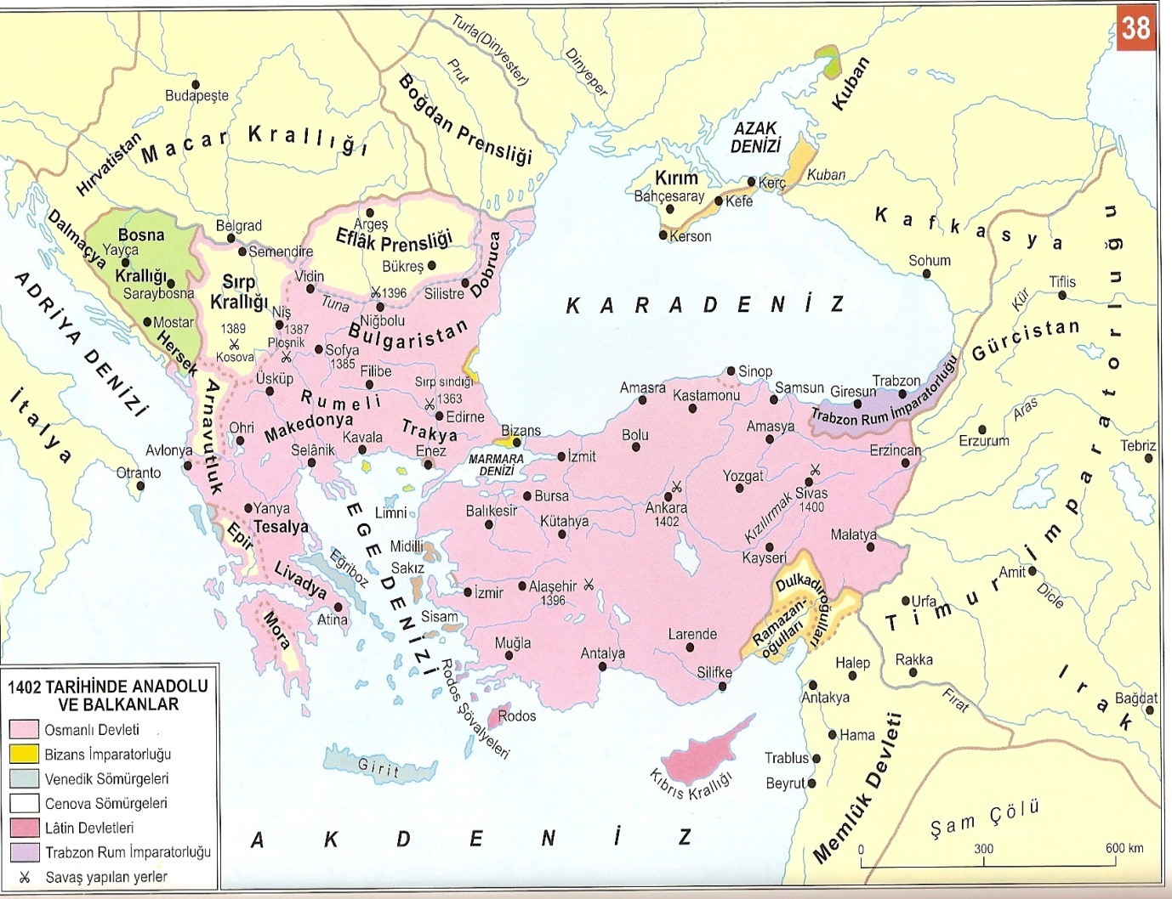
Aşağıdaki yerleşim yerlerini haritada bularak bu yerleşim yeri ile ilgili tarihi bir cümle kurunuz.
Selanik……………………………………………………………………………………..
…………………………………………………………………………………………………
Tuna……………………………………………………………………………………..
…………………………………………………………………………………………………
Niğbolu…………………………………………………………………………………..
…………………………………………………………………………………………………
Ankara……..……………………………………………………………………………..
…………………………………………………………………………………………………
Fırat….……………………………………………………………………………………..
…………………………………………………………………………………………………

Bursa………………………………………………………………………………………………………………………………………………………………………………………………………………………………………………………………
Bizans……………………………………………………………………………………………………………………………………………………………………………………………………………………………………………………………
Edirne……………………………………………………………………………………………………………………………………………………………………………………………………………………………………………………………
Bosna………………………………………………………………………………………………………………………………………………………………………………………………………………………………………………………………
Eflak………………..………………………………………………………………………………………………………………………………………………………………………………………………………………………………………………

